

A REPORT ON MY STUDY EXPERIENCE IN AKIRACHIX FOR THE LAST THREE WEEKS

a report of February 26, 2019 on the different courses i take

Introduction to Computer

* I have learnt about how to open and close a computer, the different external and internal parts of a computer.
* I have learnt to open an email account, how to send an email and to go incognito.
* I have learnt how to type, create and save a document. How to create a folder and a file.
* I have learnt how to take care of my laptop.
* The subject is taught by Mr. Pascal Aloo.



Graphics Design.

* It is the art of combining texts and pictures in advertisements magazines and books.
* It is the use of visual concept using a computer software by hand to communicate ideas that captivate consumers.
* I have learnt how to make curves and lines in images using the pen tool.
* Taught by Mrs. Nyandia Kamawe



Hardware and Electronics.

* Hardware design is designing and coming up with a product that is beneficial to the target market.
* Electronics involves capacitors, resistors, transistors and integrated circuits.
* I have learnt how to calculate voltage and currents, how to come up with and manage my products.
* Subject taught by Mr. Bare Yassin.

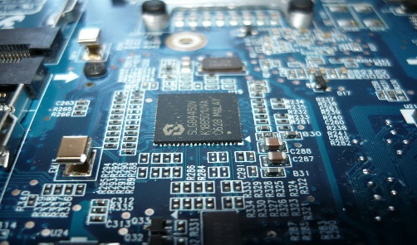

Entrepreneurship.

* I have learnt about the definition of entrepreneurship and types, and how to identify opportunities.
* Have learnt about different types of entrepreneurs and their characteristics, and the difference between inventors and innovators.
* Taught by Mrs. Kelly Murungi.



Python.

* I have learn its purpose, when it was discovered and by who.
* I have practiced how to use python in the computer.
* Subject taught by Mr. James Mwai.



HTML CSS.

* I have learnt how to open and close a tag, creating a website and the different form of making a HTML code.
* By Mr. Jeff Muthondu.

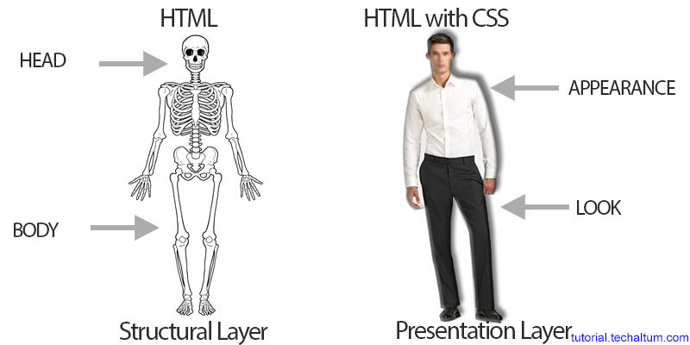

Life Skills.

* We have listened to the TED talks on Chimamanda Adichi and Patti Dobra Wolski, gone through the dangers of a single story, reviewed 2018 and 2019 and gone through Home Going Novel. 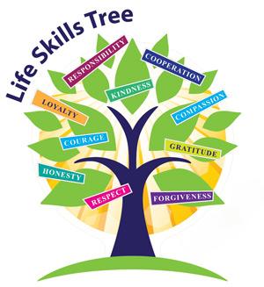
* Taught by Mrs. Veronica Nyokabi.

CONCLUSION.

* Mobile Development and Java Script haven’t been taught to us just yet. But hopefully we’ll get a teacher before end of the month.

RECCOMMENDATION.

* The experience has been amazing so far, and am hoping to come out of here successful and more productive.